**The Battle of Neighborhoods**

**Opening a Thai restaurant in Bucharest**

*IBM Data Science Professional Certificate – Capstone Project*

*Butulan Gabriela Daniela*

*January 2021*

1. **Introduction**

Bucharest is the capital and largest city of Romania, as well as its cultural, industrial, and financial centre. It is in the southeast of the country, at 44°25′57″N 26°06′14″ECoordinates: 44°25′57″N 26°06′14″E, on the banks of the Dâmbovița River, less than 60 km (37.3 mi) north of the Danube River and the Bulgarian border.

Bucharest was first mentioned in documents in 1459. It became the capital of Romania in 1862 and is the centre of Romanian media, culture, and art. Its architecture is a mix of historical (Neoclassical and Art Nouveau), interbellum (Bauhaus, and Art Deco), communist era and modern. In the period between the two World Wars, the city's elegant architecture and the sophistication of its elite earned Bucharest the nickname of 'Paris of the East' (Romanian: Parisul Estului) or 'Little Paris' (Romanian: Micul Paris). Although buildings and districts in the historic city centre were heavily damaged or destroyed by war, earthquakes, and even Nicolae Ceaușescu's program of systematization, many survived and have been renovated. In recent years, the city has been experiencing an economic and cultural boom. It is one of the fastest-growing high-tech cities in Europe, according to Financial Times, CBRE, TechCrunch, and others.

1. **Problem**

In this project, I will analyze if there is a place for a new thai restaurant to be opened in Bucharest.

1. **Interest**

Anyone wants to open a new venue in any geographic location may be interested in this project by modifying search criteria.

1. **Data**
2. **Data sources**

To consider the problem we can list the data as below:

* Sectors of Bucharest data have been used from Wikipedia
* Neighborhood data of Bucharest has been used from Wikipedia
* Python geocoder library was used to get geographical coordinates of neighborhoods
* I used **Foursquare API** **venues explore** method to get the venues of given neighborhoods of Bucharest
* I used **Foursquare API venues method** to get likes and ranks of restaurants by given venue id

1. **Feature Selection and Data Usage**

* I used neighborhood location values to analyze Bucharest geographical structure. I used folium library of python to draw maps by using given latitude and longitudes of neighborhoods. Selected features will be as below

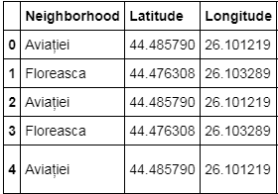

* I will use populations of neighborhoods which have high population that may need a new restaurant.

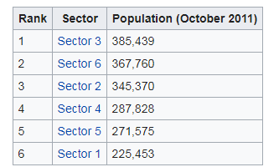 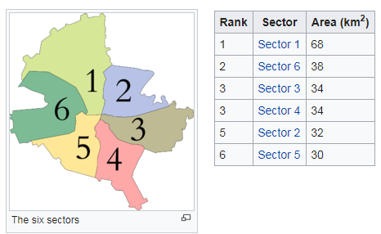

* I will also classify neighborhoods by using venues distribution and counts. In this way, I will find similarities of neighborhoods which will help me to choose location for opening a new restaurant.

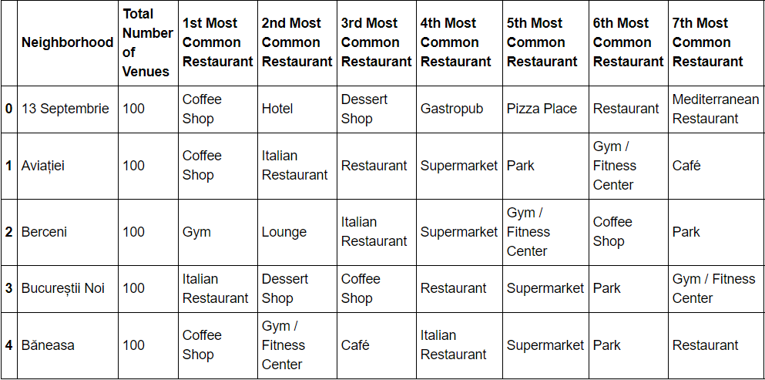

# 5. Methodology

* I used GitHub - Gist repository for code versioning.
* Bucharest data is available with the neighborhood name in Wikipedia. Location information (latitude and longitude) of neighborhoods are taken from geocoder library.
* I used neighborhoods from Wikipedia to see centers of neighborhoods. There are 40 neighborhoods in Bucharest.
* I also got sector names of neighborhoods and populations of sectors. There are 6 sectors in Bucharest. I also merged Sector and Neighborhood data to see in which sector neighborhood places.

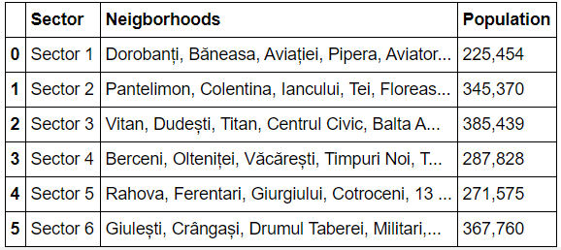

* There are 170 unique venue categories in Bucharest and top 10 venue counts is as below

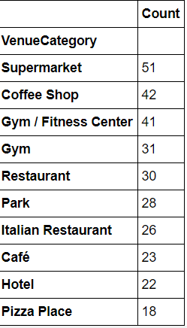

* I filtered all the restaurants and Thai restaurants. We can see from histogram of restaurants; 32 neighborhoods have no Thai restaurant.

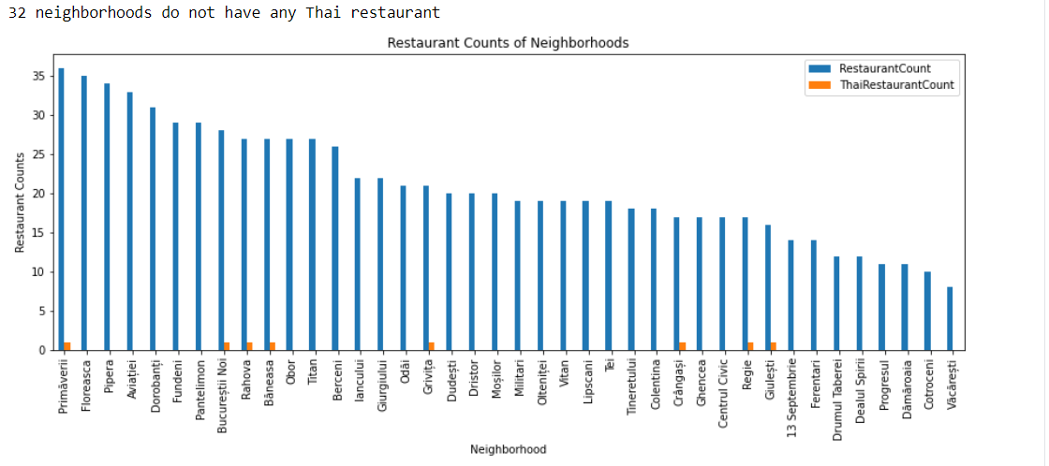

1. **Results**

There is just 1 thai specific restaurant opened in Bucharest, the other Asiatic restaurants have also included thai specific but are not exclusively thai restaurants.

1. **Discussion**

Clusters 1, 2, 3 and 5 have a lack of restaurants so most likely a thai restaurant can be opened there but we should also keep in mind that a centrally location is more visited by locals and tourists, therefore in the conclusion I will present the 3 options that I choose based on the lack of thai restaurants and location near city center.

1. **Conclusion**

I have chosen 3 locations for opening Thai restaurants. Floreasca, Aviatei and Dorobanti have a lot of restaurants but none of them is thai and they are centrally located which means that a thai restaurant can have success there.